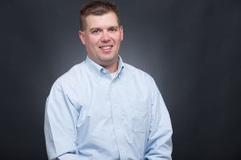
Dr. Matt Feldmann is the principal researcher and owner of Goshen Education Consulting Inc, in Edwardsville, Illinois…the furthest southern suburb of Chicago. He started the company in 2009 due to the untapped need to provide data interpretation and evaluation services to the educational communities in Southwestern Illinois. Goshen Education Consulting is a reflection of his background, interests, skills and opportunities that include deep data analysis, clear and concise reporting, and a focus on program development. Since its founding, Dr. Feldmann and Goshen Education Consulting have led 24 U.S. Department of Education Math and Science Partnership evaluation projects and has been involved with the Illinois Math & Science state-wide evaluation team for Math and Science Partnerships. Beyond the U.S. Department of Education projects, he also has led multiple education evaluation projects with the National Science Foundation, Department of Defense, W.K. Kellogg Foundation, United Way, Monsanto, Astellas, Swarovski and the Illinois Biotechnology Institute EDUCATE Center. Dr. Feldmann is a frequent speaker on how to conduct rigorous evaluations and a frequent presenter with his clients concerning the management and outcomes of their projects. Professionally he was the chair of the American Evaluation Association’s (AEA) Independent Consulting Topical Interest Group and is the current president of the AEA local affiliate, the Evaluation Association of St. Louis.

